SAP Cloud ERP
June 2026
English
Two -Tier scenario: Project Based Engineer-to-Order
Customer Guide

Copyright
© 2025 SAP SE or an SAP affiliate company. All rights reserved.
No part of this publication may be reproduced or transmitted in any form or for any purpose without the express permission of SAP SE. The information contained herein may be changed without prior notice.
Some software products marketed by SAP SE and its distributors contain proprietary software components of other software vendors.
National product specifications may vary.
These materials are provided by SAP SE and its affiliated companies ("SAP Group") for informational purposes only, without representation or warranty of any kind, and SAP Group shall not be liable for errors or omissions with respect to the materials. The only warranties for SAP Group products and services are those that are set forth in the express warranty statements accompanying such products and services, if any. Nothing herein should be construed as constituting an additional warranty.
SAP and other SAP products and services mentioned herein as well as their respective logos are trademarks or registered trademarks of SAP SE in Germany and other countries. Please see http://www.sap.com/corporate-en/legal/copyright/index.epx#trademark for additional trademark information and notices.

Revision | Change Date | Description
0 | 03-01-2023 | Initial version of document
1 | 25-05-2026 | Adaptation w.r.t to new Strategy & Nomenclature

Icons

Icon | Meaning
 | Caution
 | Example
 | Note
 | Recommendation
 | Syntax

Typographic Conventions

Type Style | Description
Example text | Words or characters that appear on the screen. These include field names, screen titles, pushbuttons as well as menu names, paths and options.  Cross-references to other documentation.
Example text | Emphasized words or phrases in body text, titles of graphics and tables.
EXAMPLE TEXT | Names of elements in the system. These include report names, program names, transaction codes, table names, and individual key words of a programming language, when surrounded by body text, for example, SELECT and INCLUDE.
Example text | Screen output. This includes file and directory names and their paths, messages, source code, names of variables and parameters as well as names of installation, upgrade and database tools.
EXAMPLE TEXT | Keys on the keyboard, for example, function keys (such as F2) or the ENTER key.
Example text | Exact user entry. These are words or characters that you enter in the system exactly as they appear in the documentation.
<Example text> | Variable user entry. Pointed brackets indicate that you replace these words and characters with appropriate entries.

Content
1 Purpose 6
2 Value Proposition 6
2.1 Business Requirements 6
2.2 Two-Tier Solution 6
3 Business Process Details 6
3.1 Prerequisites 7
3.2 Process Flow with Technical Details 7
4 Technical Requirement 9
5 Test Procedure 9
5.1 Prerequisites 10
5.1.1 System Details 10
5.1.2 Creation of custom development-based integration 10
6 Appendix 10
6.1 Relevant Scope ID’s 10

Two-Tier-Transportation planning of external requirements

Purpose
This accelerator document covers the two-tier headquarters and subsidiary scenario covering project-based engineer-to-order (ETO) between SAP Cloud ERP and SAP Cloud ERP (Private). The APIs referred in this document are available for consumption from api.sap.com.

Value Proposition

Business Requirements
The need to have an integrated end-to-end business process set up for project-based manufacturing.
With project and sales order based read and write APIs, helps the required manufacturing related task information flow from headquarters to subsidiary and the confirmation back from subsidiary to headquarters.

Two-Tier Solution
The Two -Tier Solution provides the API based direct integration between SAP Cloud ERP system at the subsidiary and SAP Cloud ERP (Private) system at headquarters or vice-versa.

Business Process Details
The purchase order creation in tier 1 (headquarters) initiates the process of creating corresponding project and sales order in tier 2 (subsidiary).

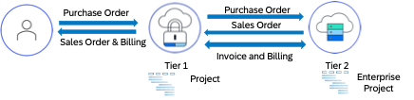

Process flow case 1: The following steps elaborate end-to-end flow when headquarters is on SAP Cloud ERP (Private) and subsidiary is on SAP Cloud ERP system:
- The headquarters creates a purchase order in SAP S/4HANA system.
- The purchase order in the headquarters SAP S/4HANA system creates an IDOC which triggers API in subsidiary running SAP S/4HANA Cloud Public Edition system.
- The API enterprise project is triggered to create project and wbs element required to execute the project in subsidiary SAP Cloud ERP system.
- Upon successful execution of the project create API, cloud integration triggers the creation of the sales order using API sales order (A2X).
- The fields required for creation of enterprise project, wbs element and sales order can be derived by maintaining mapping in SAP cloud integration, the mapping will be maintained between the headquarter purchase order fields and the subsidiary project, wbs element and sales order fields.
- The production process is triggered by material requirement planning (MRP) run for BoM components. Once the finished product is manufactured (and confirmations entered and components issued) and received into stock, the delivery and final billing occurs.
- The flow of customer invoice raised in subsidiary will be interfaced to headquarters via SAP cloud integration.

Process flow case 2: The following steps elaborate end-to-end flow when headquarters is on SAP Cloud ERP and subsidiary is on SAP Cloud ERP (Private) system:
- The headquarters creates a purchase order in the SAP Cloud ERP system.
- The purchase order in the headquarters SAP Cloud ERP system automatically creates a sales order in the subsidiary SAP S/4HANA system.
- In subsidiary, the material must be linked to a standard network and standard Work breakdown structure in CN09 to follow the Assembly processing.
- Project manager can be assigned to the project in subsidiary who can go ahead and create a detailed project plan.
- The sales order triggers the creation of an operational network and operational project in subsidiary SAP S/4HANA system.
- The production process is triggered by material requirement planning (MRP) run for BoM components. Once the finished product is manufactured (and confirmations entered and components issued) and received into stock, the delivery and final billing occurs.
- Based on the type of invoicing, subsidiary can proceed with the billing for the execution between headquarters and subsidiary.

Prerequisites
The following list of prerequisites are to be in place to realize the business process,
- Integration setup between headquarter and subsidiary with SAP Cloud Integration.
- Replicate the material master data between headquarters and subsidiary.
- If subsidiaries are on SAP Cloud ERP, set up 2EL scope to automate exchange of sales documents and the follow-on messages.
- If headquarters are on SAP Cloud ERP, set up 2EJ scope to automate exchange of procurement documents and the follow-on messages.

Process Flow with Technical Details

Process flow case 1: When headquarters is on SAP Cloud ERP (Private) and subsidiary is on SAP Cloud ERP system:
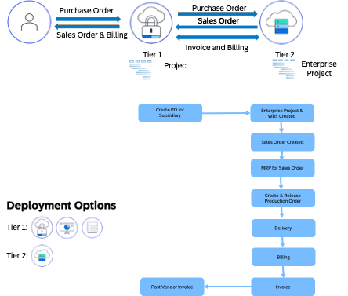

Process flow case 2: When headquarters is on SAP Cloud ERP and subsidiary is on SAP Cloud ERP (Private) system:
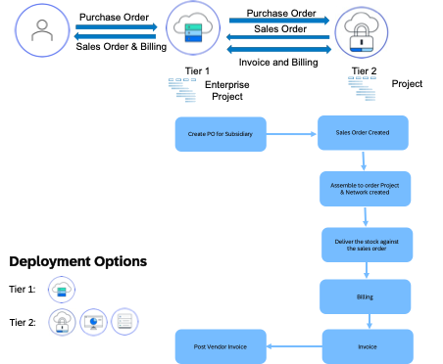

Technical Requirement
Communication scenarios are set up using communication arrangements tool for respective data as follows:
Communication arrangement ID | Name
SAP_COM_0308 | Enterprise Project Integration
SAP_COM_0109 | Sales Order Integration

Help documentation reference enterprise project API: https://help.sap.com/docs/SAP_S4HANA_CLOUD/988903b47d7040f6ac4ec02e44bb58e4/35f5f46c6bb14edead3851c8ecfde7a0.html

Test Procedure

Prerequisites
This section summarizes all prerequisites to conduct the test in terms of systems, users, master data, organizational data, and other test data and business conditions.

System Details
The test scenario can be built in the following two-tier system landscape:

System | Details
SAP Cloud ERP (Private) | SAP Cloud ERP (Private) version 1909 or higher
SAP Cloud ERP | SAP Cloud ERP, 2208 release or higher

Creation of custom development-based integration
- There is no custom development needed to be implemented to realize this integration.

Appendix

Relevant Scope ID’s
The Cloud APIs are relevant for the following scope item IDs in EPPM (Enterprise Portfolio and Project Management) and Two-Tier.
Project Control – Sales (4I9)
Integration of Sales with External Buyers (‏2EL‏)
Integration of Procurement with External Suppliers (‏2EJ‏)

